2.58: a) The space per vehicle is the speed divided by the frequency with which the cars pass a given point;
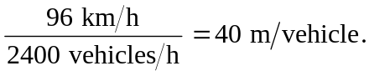

An average vehicle is given to be 4.5 m long, so the average spacing is 40.0 m – 4.6 m
= 35.4 m.

b) An average spacing of 9.2 m gives a space per vehicle of 13.8 m, and the traffic flow rate is
